Bird Photo Credit and Copyright

Photographer: Atsushi Nishijima
© 2024 House Bird Limited, Ad Vitam Production, Arte France Cinema, British Broadcasting Corporation, The British Film Institute, Pinky Promise Film Fund II Holdings LLC, FirstGen Content LLC and Bird Film LLC. All rights reserved

Character: Bailey
Actor: Nykiya Adams

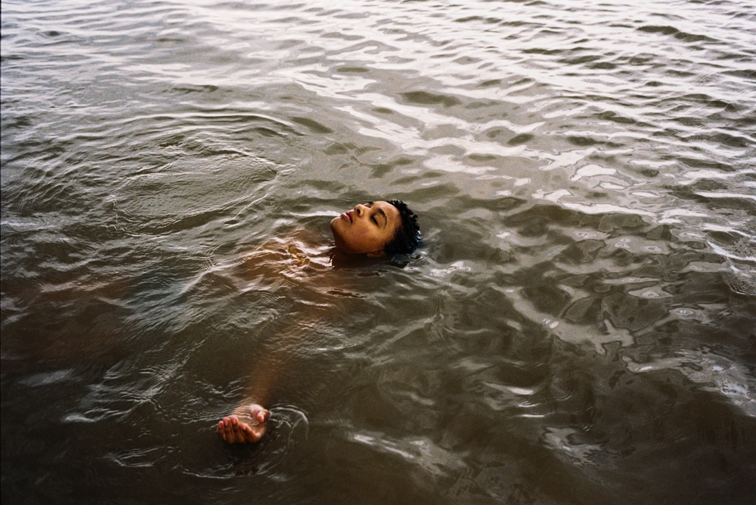

Photographer: Atsushi Nishijima
© 2024 House Bird Limited, Ad Vitam Production, Arte France Cinema, British Broadcasting Corporation, The British Film Institute, Pinky Promise Film Fund II Holdings LLC, FirstGen Content LLC and Bird Film LLC. All rights reserved

Character: Bird
Actor: Franz Rogowski

